**HASSAN ANWAR**

**BSEF12M014**

**HTA**

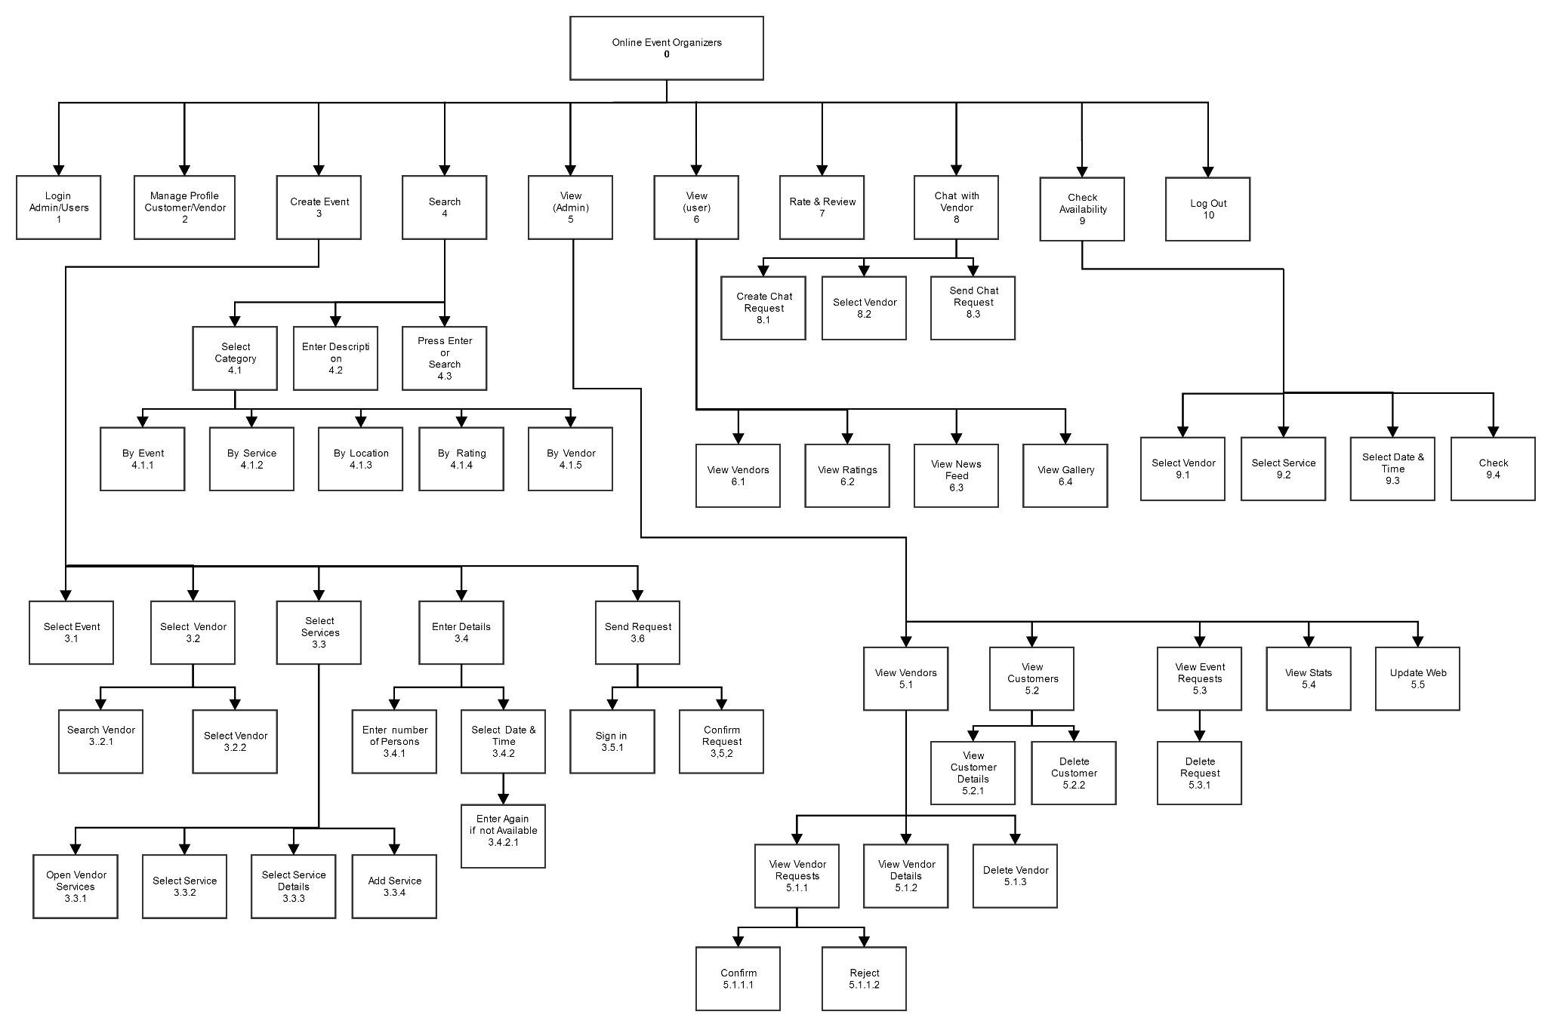

Plans

**Plan 0:** Do 1 then do 2, 5, 6, 7, 8 in any order until 10; Do 3, 4, 9 in any order;

**Plan 3:** Do 3.1 then repeat 3.2, 3.3 and 3.4 in sequence then do 3.5;

**Plan 4:** Do 4.1, 4.2, and 4.3 in any sequence;

**Plan 5:** Do 5.1, 5.2, 5.3, 5.4 and 5.5 in any order;

**Plan 6:** Do 6.1, 6.2, 6.3 and 6.4 in any order;

**Plan 8:** Do 8.1, 8.2, and 8.3 in any sequence;

**Plan 9:** Do 9.1, 9.2, 9.3 and 9.4 in sequence;

**Plan 3.2:** Do 3.2.1 and 3.2.2 in sequence;

**Plan 3.3:** Do 3.3.1, 3.3.2, 3.3.3 and 3.3.4 in sequence;

**Plan 3.4:** Do 3.4.1 or 3.4.2 in any order;

**Plan 3.5:** Do 3.5.1 and 3.5.2 in sequence or do 3.5.2;

**Plan 4.1:** Do 4.1.1 or 4.1.2 or 4.1.3 or 4.1.4 or 4.1.5;

**Plan 5.1:** Do 5.1.1, 5.1.2 and 5.3.3 in any order;

**Plan 5.1.1:** Do 5.1.1.1 or 5.1.1.2;

**Plan 5.2:** Do 5.2.1 and 5.2.2 in sequence;

**Plan 5.3:** Do 5.3.1;

**Online Event Organizers:**

Create Event:

* Initiate the Create Event process (M)
* Point to the Create Event (P)
* press and hold mouse button (B)
* release mouse button (B)
* Point to the Select Event (P)
* press and hold mouse button (B)
* release mouse button (B)
* Point to the Select Vendor (P)
* press and hold mouse button (B)
* release mouse button (B)
* Switch to keyboard (H)
* Press the key to Search Vendor (K)
* Scroll to select the Vendor(B)
* Select the Vendor (B)
* Switch to Mouse (H)
* Point to Select Service of Vendor (P)
* press and hold mouse button (B)
* release mouse button (B)
* Point to Select Service Details of Vendor (P)
* press and hold mouse button (B)
* release mouse button (B)
* Point to Add Service Button (P)
* press and hold mouse button (B)
* release mouse button (B)
* Switch to Keyboard (H)
* Press the key to Enter number of Persons (K)
* Switch to Mouse (H)
* Point to Calendar Button to Select Date (p)
* press and hold mouse button (B)
* release mouse button (B)
* Press the key to Select Date (B)
* Press the key to Select Time (B)
* Point to Send Request (P)
* Press and hold mouse button (B)
* Release the mouse button (B)
* Switch to Keyboard (H)
* Press the key to Enter ID (K)
* Press the key to Enter Password (K)
* Switch to Mouse (H)
* Point to the Confirm Request button (P)
* Press and hold the mouse button (B)
* Release the mouse button (B)
* Check the response of the system (S)
* point to original window (P)

M+ 10P + 22B + 3K + S + 6H

= (1*1.35) + (10*1.1) + (22*0.1) + (3*0.20) + 0.1 + (6*0.4) = 17.65 sec